**LAB NAME : AI ASSISTED CODING**

**LAB NUMBER :02**

**ROLL NO :2503A51L30**

**BRANCH : CSE**

**NAME :B .MAHESH**

**TASK 1**

**TASK DESCRIPTION: Open Google Colab and use Google Gemini to generate Python code that performs sorting of a list using both the bubble sort algorithm and Python’s built-in sort() function. Compare the two implementations.**

**PROMPT:** **Generate Python code that sorts a list of integers using two methods: (1) the bubble sort algorithm implemented manually, and (2) Python’s built-in `sort()` function. Then compare the performance and output of both methods using a randomly generated list of 1000 integers. Include timing analysis using the `time` module and print the sorted results to verify correctness.**

**CODE:**

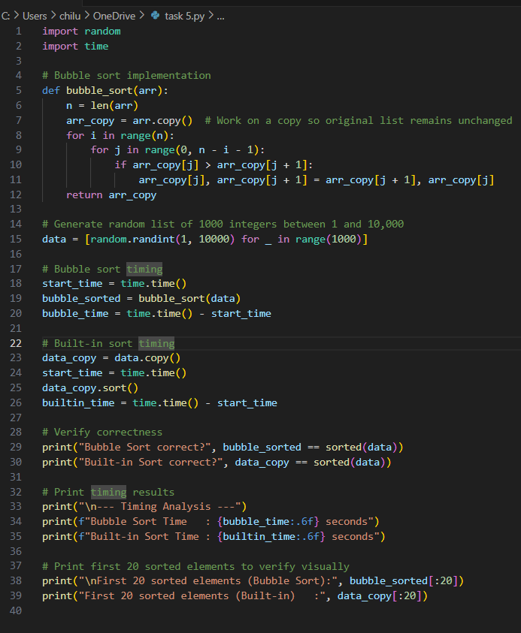

**TASK 2**

**TASK DESCRIPTION: In Colab, use Google Gemini to generate a Python function that takes a string and returns:**

**The number of vowels, The number of consonants, The number of digits in the string**

**PROMPT: Write a Python function that takes a string as input and returns three values: the number of vowels, the number of consonants, and the number of digits in the string. Ignore spaces and special characters. Make sure the function handles both uppercase and lowercase letters. Include a sample input and output to demonstrate the function**

**CODE**

**OUTPUT:**

**TASK 4**

**TASK DESCRITPION: Ask Google Gemini to generate a Python program that implements a simple calculator using functions (add, subtract, multiply, divide). Then, ask Gemini to explain how the code works.**

**PROMPT: Generate a Python program that implements a simple calculator using functions for addition, subtraction, multiplication, and division. The program should take two numbers and an operator as input, then call the appropriate function and display the result. After generating the code, explain how each part of the program works, including how the functions are defined and called.**

**CODE:**

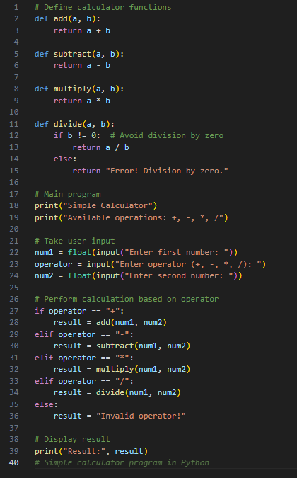

**OUTPUT:**

